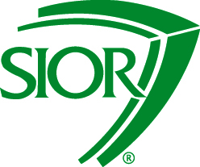

2015 Chapter Admissions Chairs Resources
5. SIOR Staff Contacts

SIOR Staff is here to assist Chapter Admissions Chairs and can provide information and answer any questions.
Michael Topp, Director of Membership
Phone: (202) 449-8216
Email: mtopp@sior.com
Sumner Crosby, Manager of Admissions
Phone: (202) 449-8234
Email: scrosby@sior.com
Alison Goldberg, Membership Coordinator
Phone: (202) 449-8220
Email: agoldberg@sior.com

