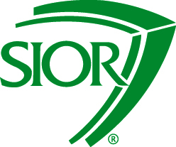
2015 SIOR Chapter Admissions Chair Toolkit

4. Chapter Admissions Chair Role

Chapter Admissions Chair Review
- Chapter Admissions Chair receives Application and Interview Form from the Manager of Admissions.
- Chapter Admissions Chair has 30 days to conduct the interview and complete the Interview Form
- Interview Form is returned to the Manager of Admissions and applicant is put on the monthly COPs vote.

Interview Form – Guides Interview process
The Chapter Admissions Chair must answer the following:
- Application Complete?
- Interview Conducted?
- GFI Affidavit Reviewed and Requirement Met?
- Has Real Estate License?
- Ethical/Criminal History

The Chapter Admissions Chair has the right to request further review by the Admissions Committee to verify:
- GFI Affidavit
- Specialty Declaration
- City/Mark choice if other than office location
Announcement to Chapter – 10 day comment period
Application Received at SIOR HQ
COPs Vote
Welcome to SIOR!
SIOR Application Timeline

1 5 10 15 20 25 30 35 40 45 50 55 60 65 70 75 80 85
Recommendations received at SIOR HQ
Application sent to Chapter – 30 day review period
Recommendation Forms sent to Applicant (60 days limit)

Signed Interview Form due to SIOR HQ
2014 SIOR Chapter Admissions Chair Toolkit

